ContactManagement_Verify Contact notes _Instance44_12-Jul-2018_05-38-52_AM_Validatingcontactentitynavigation.png

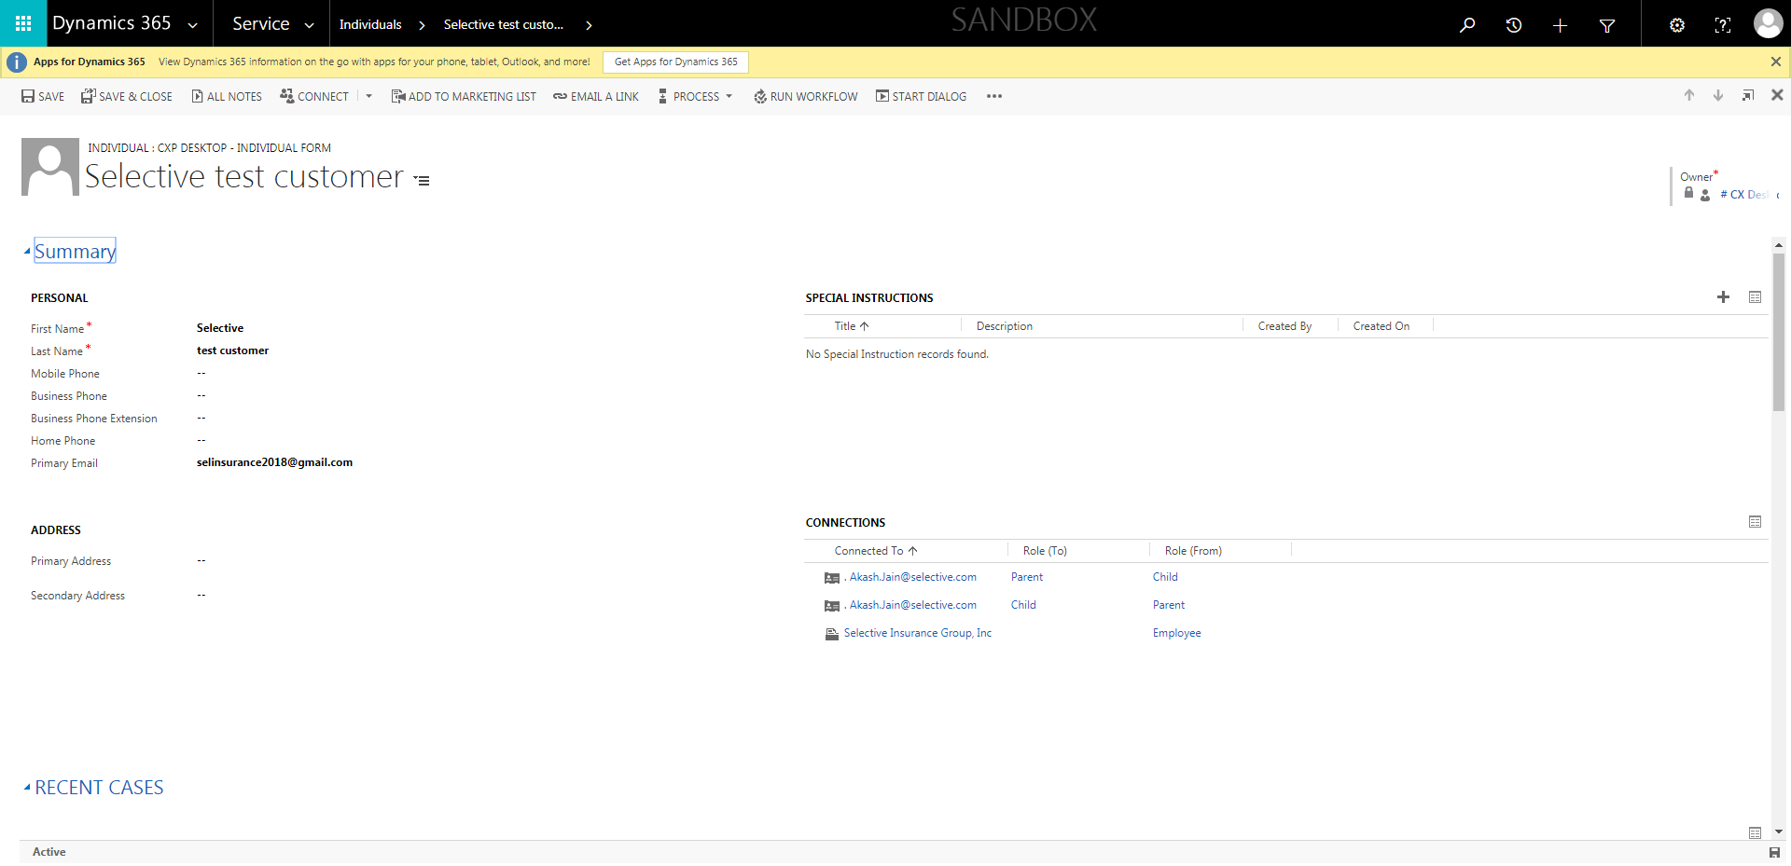

ContactManagement_Verify Contact notes _Instance44_12-Jul-2018_05-37-43_AM_SingleSignOn.png

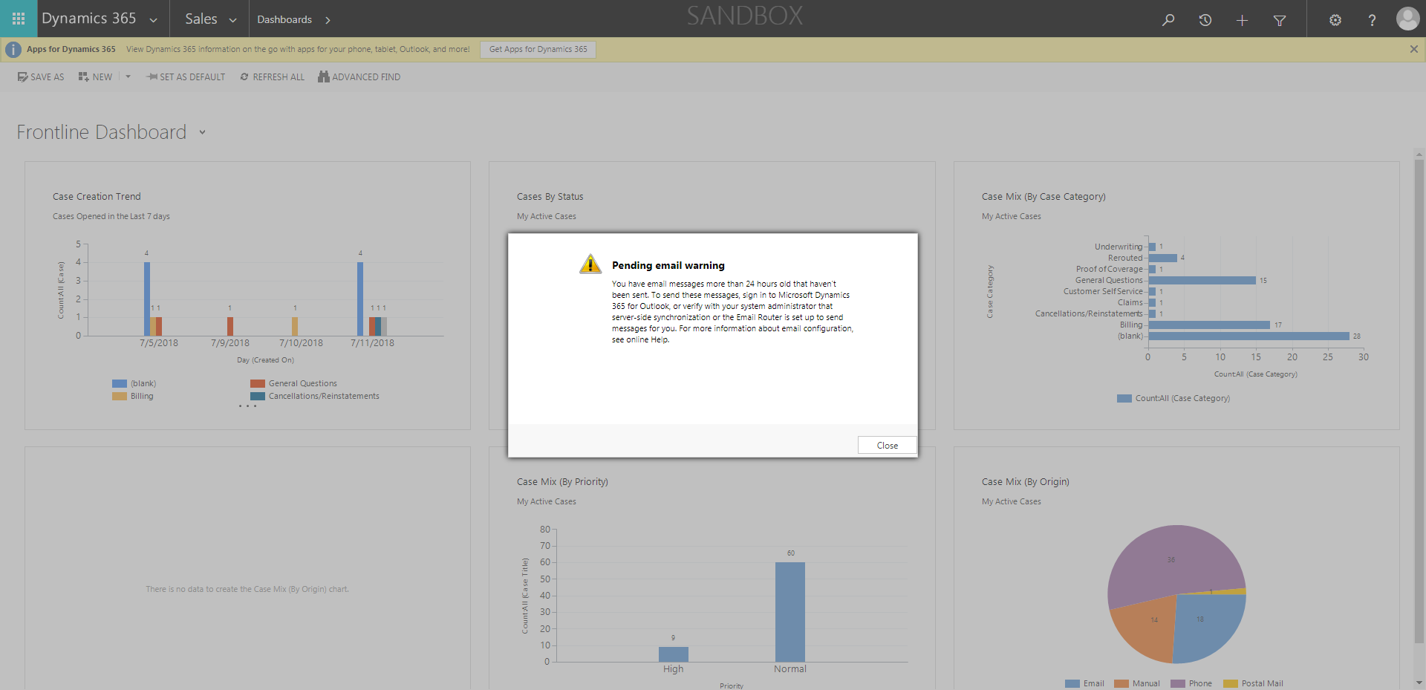

ContactManagement_Verify Contact notes _Instance44_12-Jul-2018_05-37-47_AM_SingleSignOn.png

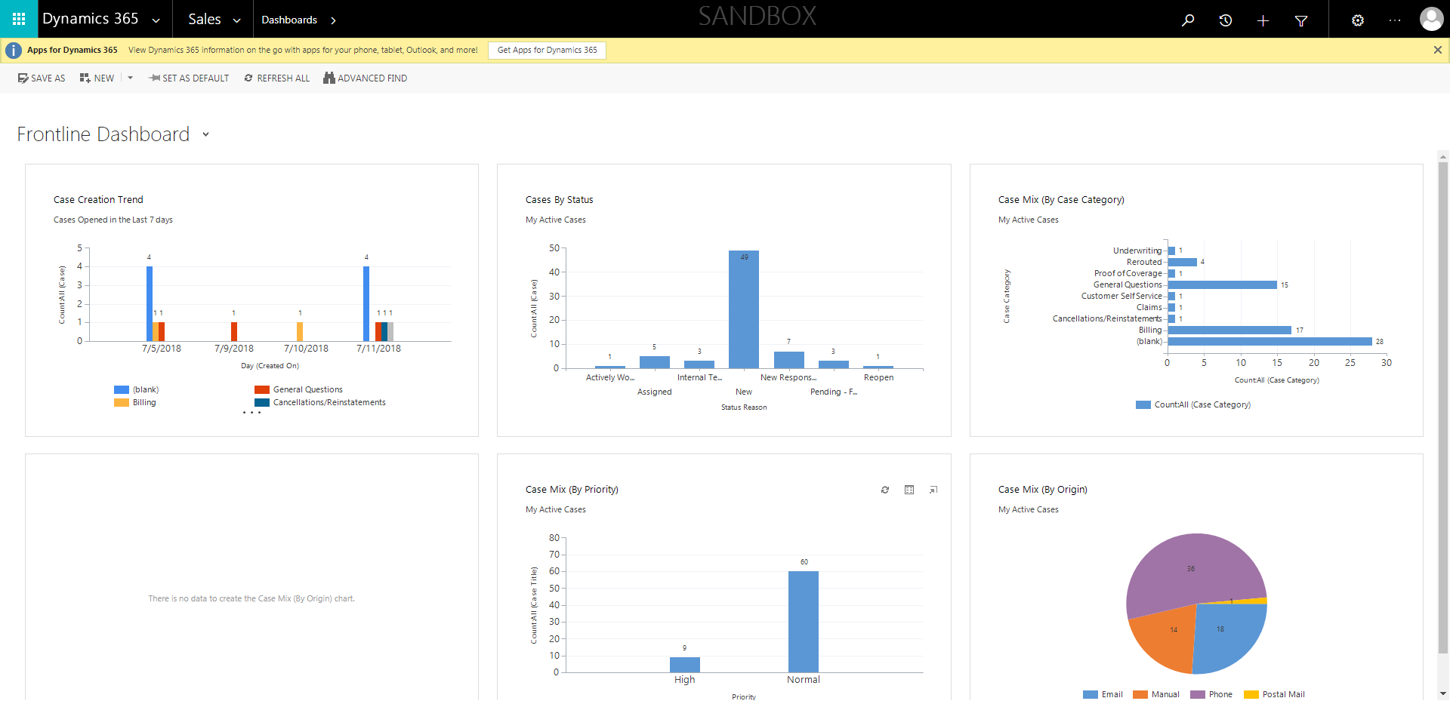

ContactManagement_Verify Contact notes _Instance44_12-Jul-2018_05-37-29_AM_EnterTextAction.png



ContactManagement_Verify Contact notes _Instance44_12-Jul-2018_05-37-28_AM_MouseClickActiononStaleElement.png



ContactManagement_Verify Contact notes _Instance44_12-Jul-2018_05-38-56_AM_VerifyingAllNotesofanindividual.png

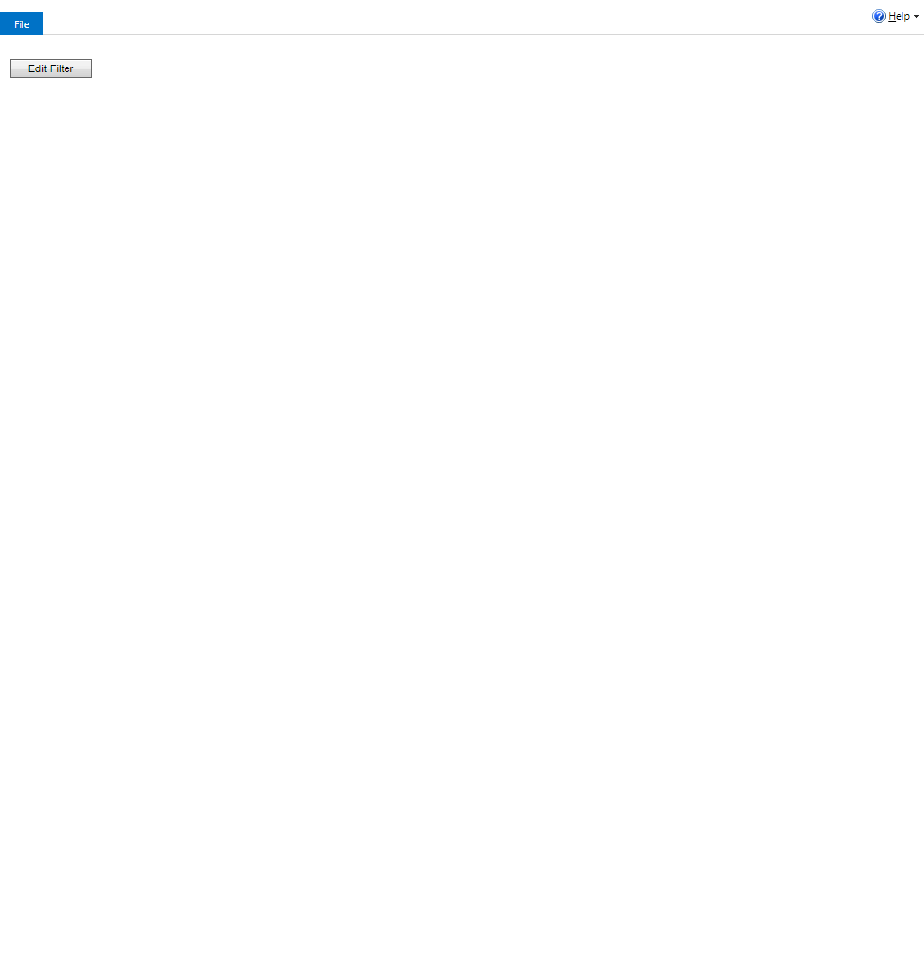

ContactManagement_Verify Contact notes _Instance44_12-Jul-2018_05-37-30_AM_MouseClickActiononStaleElement.png

